Practical: 3 | To implement Heap Sort using the Heapify technique in C++ and analyze its time complexity
12/07/2026

Aim: To implement Heap Sort using the Heapify technique in C++ and analyze its time complexity

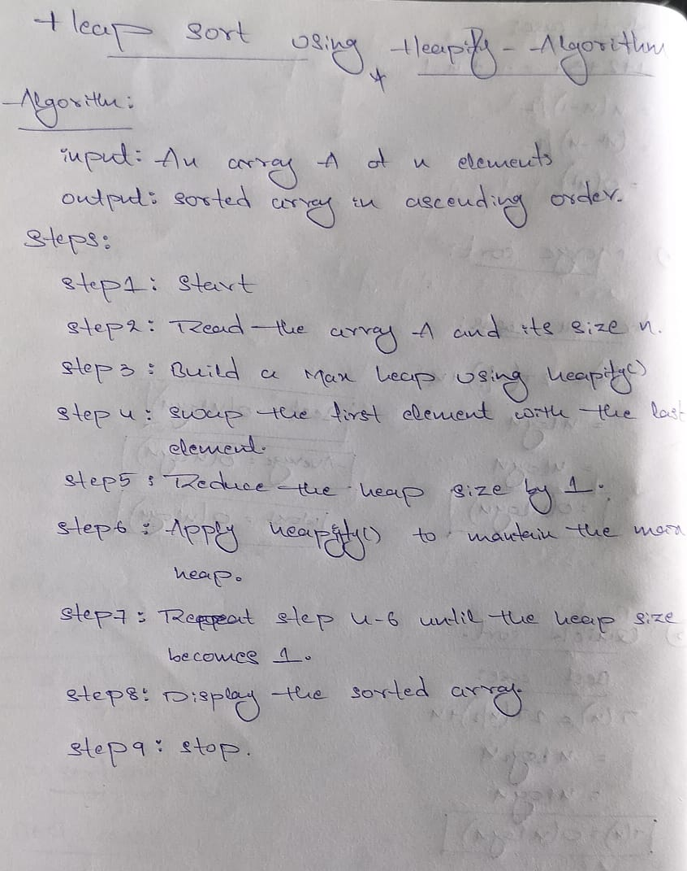

Program:

1. heap sort:
#include <iostream>
using namespace std;

void heapify(int arr[], int n, int i)
{
int largest = i;
int left = 2 * i + 1;
int right = 2 * i + 2;

if (left < n && arr[left] > arr[largest])
largest = left;

if (right < n && arr[right] > arr[largest])
largest = right;

if (largest != i)
{
swap(arr[i], arr[largest]);
heapify(arr, n, largest);
}
}

void heapSort(int arr[], int n)
{
for (int i = n / 2 - 1; i >= 0; i--)
heapify(arr, n, i);

for (int i = n - 1; i > 0; i--)
{
swap(arr[0], arr[i]);
heapify(arr, i, 0);
}
}

int main()
{
int arr[] = {12, 11, 13, 5, 6, 7};
int n = 6;

cout << "Original Array: ";
for (int i = 0; i < n; i++)
cout << arr[i] << " ";

heapSort(arr, n);

cout << "\nSorted Array: ";
for (int i = 0; i < n; i++)
cout << arr[i] << " ";

return 0;
}

Output:

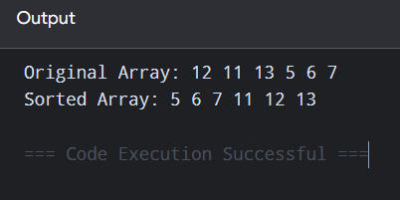

Time Complexity:

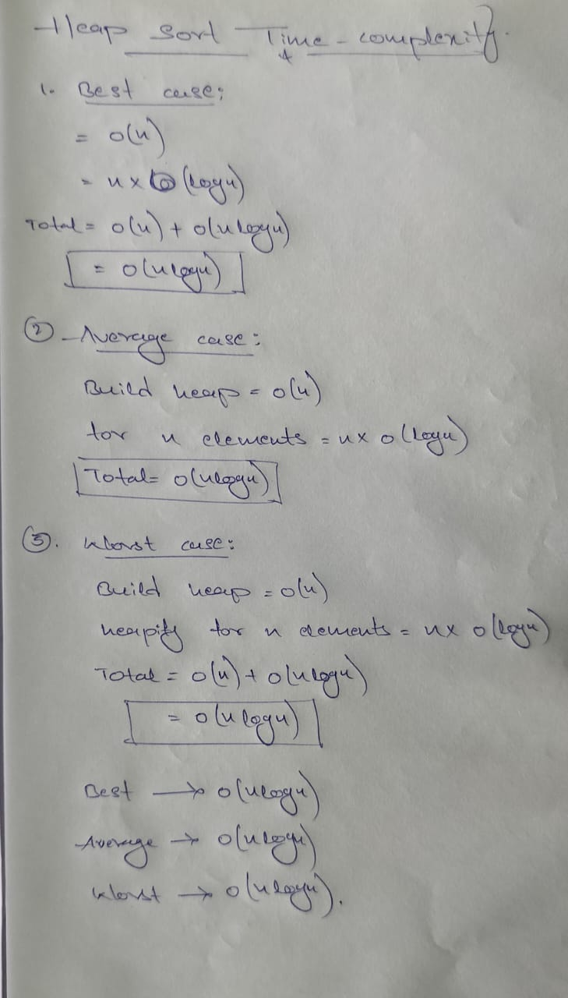

Conclusion:
Heap Sort was successfully implemented using the Heapify technique. The array was sorted in ascending order with O(n log n) time complexity.

